Special Release!

Helpful Information About
the Recent Market Volatility
Charles L. Schlapp, CFP®

For nearly 10 years now, the stock market has been practically unstoppable. Both the 122-year-old Dow Jones Industrial Average and the S&P 500 had quadrupled earlier this year from their March 2009 lows. Many investors who've held throughout a couple of interruptions since then have been handsomely rewarded.

For a variety of reasons, October started the return of heavy short-term market turbulence and volatility. This has made it challenging for many investors. Since hitting their all-time highs, the Dow Jones has also seen correction territory (defined as a decline of more than 10%). The S&P 500 has also hit correction territory with a drop of over 10% from its all-time intraday high, and the technology heavy Nasdaq Composite has seen tougher times with declines of over 15% since hitting its peak.

Clearly, many investors may be worried, so here is some timely information that may be helpful.

Market corrections are more
common than many investors realize.
Market corrections (declines of 10% or more from a recent high point) are far more common than most people think. Since the start of 1950*, the S&P 500 has undergone 37 corrections of at least 10% and it's had quite a few other dips in the high single-digit percent range, according to data from market analytics firm Yardeni Research. That's an average of one correction in less than every two years. Although the stock market does not follow in a straight path to averages, this still demonstrates just how common declines are.

It’s almost impossible to exactly pinpoint
when corrections first occur.

Despite being so common, market corrections can come without warning and over the long run it can be near impossible to exactly figure out when they officially start. Most analysts feel that, only after a correction hits, does it become clear what caused it.

Short-term traders tend to be
impacted most during corrections
Another important aspect of stock market corrections is that many times they do not affect long-term investors as much as short-term traders. That's because many long-term investors aren't going to head to the sidelines when a 10% drop, or greater, occurs. The group that often gets most affected during corrections are the short-term traders.

Bear markets are part of the investment experience.
A bear market is normally defined as a drop of 20% or more in stock prices. By this definition, according to Bloomberg, there have been 25 bear markets since 1929. That means markets have averaged one roughly every 3.5 years or so. While a bear market can occur about once every 3.5 years, corrections occur much more frequently. Unfortunately, market averages are not neat and tidy. They trade in both short- and long-term cycles. Losses and gains tend to get clustered together. When people think of a crash today, they look at the last two (2008-09 & 2000-02) as their guides. Both basically cut the market in half.
While a drop of 20% after a gain of over 300% can occur, most analysts feel we are not beginning another equity market crash. Still as we said earlier, it’s very difficult, if not impossible to predict with much accuracy when larger drops might occur and what the severity will be. You can use history as a guide, but that doesn’t mean things will play out exactly the same way going forward. Even though the stock market has had both corrections and crashes on a regular basis, over long periods of time, equities have still provided healthy returns for many investors. Please also remember that 10 of those 25 bear markets occurred during the Great Depression and its aftermath in the 1930s.

If you would like to share this article with a friend or colleague, please call Marlena at Superior Financial Management at
(516) 939-2789 and we would be happy to assist you!

Our primary goal is to align your investments to your time horizons. We appreciate the confidence clients have in our firm.

Please have a happy holiday season and try not to get too immersed in the day to day rollercoaster ride we call the stock market!

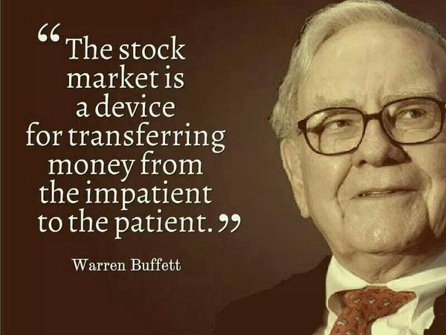
When it comes to investing, there is no magic. Many times, strong returns are the result of patience and discipline. Our mantra this year for clients has been proceed with caution and we suggest if you have any concerns, questions or changes to your situation, please call us immediately.
Chuck Schlapp is a Financial Planner with Superior Financial Management. He is a registered investment advisor affiliated with and also offers securities as a Registered Representative of North Ridge Securities Corp.
1895 Walt Whitman Road, Melville, NY 11747. Tel.: (631) 420-4242 – Member of FINRA/SIPC.
The modern design of the S&P 500 stock index was first launched in 1957. Performance back to 1950 incorporates the performance of the predecessor index, the S&P 90.
The views expressed are not necessarily the opinion of North Ridge Securities Corp., and should not be construed, directly or indirectly, as an offer to buy or sell securities mentioned herein. This article is for informational purposes only. Economic forecasts set forth may not develop as predicted and there can be no guarantee that strategies promoted will be successful. This information is not intended to be a substitute for specific individualized tax, legal or investment planning advice as individual situations will vary. For specific advice about your situation, please consult with a lawyer or financial professional. Past performance is no guarantee of future results. Investing involves risks including possible loss of principal. No investment strategy or risk management technique can guarantee return or eliminate risk in all market environments. All indices are unmanaged and cannot be invested into directly. Sources: AWealthof CommonSense.com; www.fool.com; This article provided by The Academy of Preferred Financial Advisors, Inc. ©

