Quarterly Economic Update
First Quarter 2018
Charles L. Schlapp, CFP®

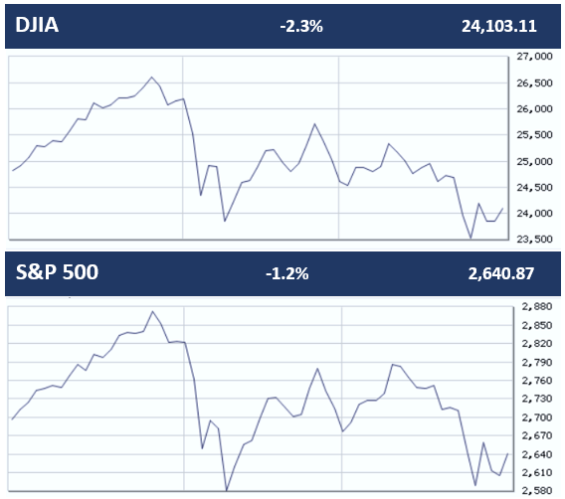
After a blockbuster start to 2018, equity markets have been caught in a vicious circle of trading over the quarter’s last two months, with volatility and uncertainty taking center stage. While a combination of factors like solid earnings, upbeat economic data and new tax legislation have fueled some rallies, inflation fears, protectionist and anti-trade Trump policies, Washington turmoil and faster-than-expected interest rate hikes continue to weigh on equity market returns.
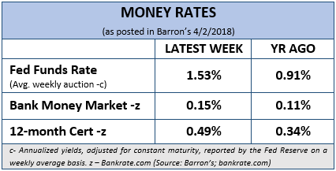
The year started out strong for equities, however, by quarter's-end the elongated period of rising share prices and low volatility finally ended. For the quarter, the Dow Jones Industrial Average posted a quarterly decline of more than 2.3%, snapping the longest streak of quarterly gains for the blue-chip average since an 11-quarter rally that ended in the third quarter of 1997. The S&P 500 index ended the quarter with a 1.2% quarterly fall, ending its long winning stretch that started in 2015.
Seeking Alpha reports that while the first quarter of 2018 marked the first time in nine quarters, (dating back to 3Q15), that the S&P 500 produced a negative total return. Six of the most recent quarters with a negative total return - 3Q15, 4Q12, 2Q12, 3Q11, 2Q10, 1Q09 - were followed up by a quarter with a positive total return.
The technology sector, which was helping equities advance, experienced huge swings in the first quarter. It was a favored investment sector for many investors for the last few years. A surge from several leading technology stocks and the emergence of new cutting-edge technologies also added to the strength. Given its strong fundamentals, over the last few years, the sector easily survived a couple of massive sell-offs according to FactSet data.

Investor disillusionment with technology stocks created some market declines in the second half of the quarter. The news of Facebook’s data breach raised regulation concerns and seemed to take the shine away from some leading technology stocks and the broader sector. Notably, Facebook eroded about $100 billion in market cap since the scandal unfolded in March. The US-China trade war announcements also took a heavy toll on equities and the technology sector. Tech stocks make up about one quarter of the S&P 500, so they need to be watched.
(Source: Barron’s 4/2/2018)
All Eyes on Interest Rates
As expected, in March, the Federal Reserve, now headed by Jerome Powell, in his first meeting raised interest rates. This sixth increase since the financial crisis was by another 0.25% bringing the new range to 1.50-1.75%. The central bank hinted at gradual hikes for this year with two more increases but turned hawkish for 2019 and 2020, citing growing confidence in the strengthening economy. As a result, some cyclical equity sectors like financials, industrials, and consumer discretionary are expected to benefit from a rising rates environment.

U.S. Federal Reserve policymakers showed, “worry over the fate of currently low inflation.” They also felt recent tax changes would provide a boost to consumer spending, according to the minutes of the U.S. central bank's policy meeting in December of 2017, which was released this quarter.
In early March, Bankrate.com reported that the current 2.9% yield on 10-year Treasuries is low by historical standards but represents an almost percentage-point jump since September, when the GOP’s $1.5 trillion tax cut package on top of an already humming economy began to look viable.
Key Points
- 2018 equity markets started strong but retreated in February and March.
- Quarter 1 of 2018 broke long quarterly winning streaks for both the DJIA and the S&P 500.
- The Fed raised U.S. Fed Fund rates to 1.50 - 1.75% in March and is scheduled to raise rates two more times in 2018.
- Heightened geopolitical and inflation concerns are influencing equity returns.
- Investors need to continue to be cautious and watchful, not emotional.
- Focus on your personal goals and call us with any concerns.
A key factor many economists are concerned with is how aggressively the Federal Reserve, with a new chairperson, will raise interest rates to stop the economy from overheating. Bankrate assembled a group of expert panelists and almost 80% expect the Fed to hike rates three times this year, similar to last year. Further increases in 2019 might also be in store as the Fed looks to bump the short-term rate to a more historically normal level. The economists were split on their predictions for the 10-year Treasury yield, but 42% forecast the yield to rise to 3.5% or more by next spring. The range of forecasts ranged from 2.28% to 4.3%. (Source: Bankrate.com 3/7/18)
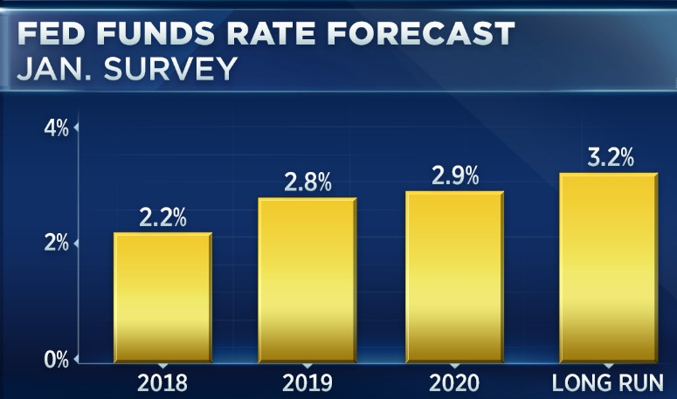
“By the latter part of 2018, markets may be anticipating another four rate hikes by the Federal Reserve in 2019 as the Tax Cuts and Jobs Act provides the economy with a significant thrust,” says Lynn Reaser, Chief Economist at Point Loma Nazarene University.
As the January CNBC Fed Funds Rate Forecast chart shows, according to CNBC, in January, 40 respondents to their survey, including economists, fund managers and strategists, now see the funds rate ending 2018 at 2.24%, up about a quarter point from the prior survey. Next year, the rate is forecast to rise to 2.8%, also a quarter point higher.
"We believe that the Fed may be forced to raise rates more rapidly than the market is currently anticipating due to accelerating economic conditions and a heating of the economy," John Roberts, director of research at Hilliard Lyons, wrote in response to the survey. "That could lead to a pullback in equity markets when combined with rising rates that make fixed-income instruments more competitive with equities."
Rising interest rates bring concerns for heavily leveraged companies. Companies can withstand higher interest rates as long as economic growth is also rising. The key question is: what level of interest rates will start to weigh meaningfully on economic activity? This is a key area that investors need to watch closely in 2018.
Other Concerning Factors
Despite a volatile stock market, the prospect of an international trade war and a declining dollar, top economists surveyed by Bankrate expect workers to enjoy positive economic news in 2018. Businesses will add to payrolls at a decent clip, the unemployment rate will decline and pay should rise, the economists predict.
(Source: Bankrate.com 3/7/18)
Global equities were shaken during the quarter by fears of a global trade war. The US administration initially announced tariffs on steel and aluminum imports. This was followed by a 25% tariff on $60 billion worth of Chinese imports (with the exact goods as yet not specified). The Chinese, in response, have announced increased tariffs on $3 billion worth of US imports. The proposed tariffs on Chinese goods amount to only about 0.1% of Chinese GDP while those on US goods are even less significant for US and global growth. That is not to say that risks to the trade outlook do not exist, but it is important to keep in perspective the size and importance of any protectionist measures that are announced.

Other than political uncertainty, the Eurozone’s economy seems to be in reasonable shape. In the UK, business surveys remain consistent with continued moderate GDP growth.
(Source: J.P. Morgan 4/3/18)

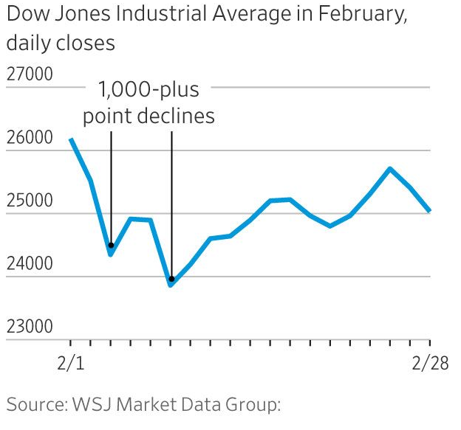
Many analysts are not yet ready to give up on this bull market. Despite the recent volatility, many analysts think the economic backdrop remains strong for stocks. “The fears of a trade war between the U.S. and China escalated this quarter following reports that the two countries were in discussions to improve U.S. access to Chinese markets. Concerns about tariffs, rising interest rates, inflation and bloated valuations have overshadowed good news like higher corporate earnings and strong economic growth”, said Joe Zidle, Investment Strategist for Blackstone Group LP. According to him, investors have yet to embrace U.S. equities, the way they have in the late stages of other bull markets. "Investors have been unwilling to embrace this bull market, and now they want to know when it's going to end," Mr. Zidle said. "The fact that so many people think it's about to end tells me it's going to keep going for a while yet."
(Source: Wall Street Journal 3/27/18)
What Should an Investor Consider?
Market bulls always insist that bull markets don't die of old age. Nine years into an extraordinary run for U.S. stocks, it's easy to buy into the idea that the only things that can halt equity markets are a recession or the Federal Reserve. According to The Wall Street Journal, that claim is only half right. Long periods of calm lead investors and companies to make silly assumptions, leaving them dangerously exposed to shifts in fundamentals. With the economy now appearing to be in the last phase of the cycle, in which the Fed starts worrying about too much growth rather than too little, some of the easy assumptions of recent years are starting to be challenged — and could threaten the most popular stocks. For nine years, U.S. investors have had easy money, higher profit margins and mostly, rising valuations, even as the economy had its slowest recovery since World War II.
(Source: Wall Street Journal 3/8/18)
As the chart of the Dow Jones Industrial Average daily closes in February shows, large market movements of 1% or more might become a regular event.
The S&P 500 moved up or down 1% or more on 23 separate occasions during the first quarter, a startling break with the precedent set in 2017 and investors may need to be more defined in their expectations. Long term investors need to resist the temptation of making emotional decisions.
Since the Great Recession, the S&P 500 has tended to produce strong returns after quarters of negative performance. Over a longer time horizon, returns have historically been positive after down quarters. Dating back to the beginning of 1927 for the S&P 500 and its predecessor indices, this market benchmark has produced positive total returns in 244 of 361 quarters (67.6% of the time).
(Source: Seeking Alpha 4/3/18)

What is a Stock Market Correction?
A stock market correction is a 10% decline in stocks from a recent high. A correction occurred during this quarter because the Dow Jones Industrial Average closed at a record high of 26,616 in January and also closed during the quarter down more than 10% from that high.

A correction is less severe than a bear market. A bear market is defined as when stocks decline 20% from their recent highs.
According to investment firm Deutsche Bank, the stock market, on average, has a correction every 357 days or about once a year. Many investors were especially emotional this time, because, although corrections happen on average once a year, the stock market's most recent correction began in the summer of 2015 and ended in February 2016. A stock market correction may be inevitable, but one thing they aren't is predictable. Stock market corrections could come about within any time frame (every few months or after multiple years) and they can be caused by a variety of issues.
While corrections affect everyone’s returns, the investors who should be most worried when corrections come about are those who've geared their trading around the short term, or those who use leverage. When asked, does this mean we're entering a recession? CNN Money wrote that, “Stock market declines don't cause recessions, and they do a pretty poor job of predicting whether one is coming. So while the market plunge might rattle investors and ding consumer confidence, it is not a sign that the economy is in trouble.” They also added that, “unemployment is at a 17-year low. Average hourly wages went up last month (January) the most in eight years. Consumer and business confidence are near record levels. Economists say it would take a much bigger stock market move than Monday's plunge (of over 1,000 points for the DJIA on 2/5/18) to change that.” (Source: CNN Money 2/6/18)
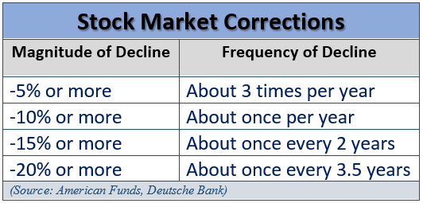
On a positive note, a stock market correction can provide a good reminder for long-term investors to reassess their holdings.
Be Careful of Emotional Investing!
For most people, investing is difficult, and being human can make it even harder. That's why even the smartest people are affected by cognitive biases, especially when it comes to investing.

Today there are hundreds of media outlets, many with 24/7 needs for news and some of these channels use fear and hype to attract viewers. CNBC reports that “since Inauguration Day, it's fair to say that many people are experiencing a volatile and highly emotional environment. Whether you're happy or unhappy with the Trump administration, upset or simply distracted by the widespread protests, raucous Cabinet confirmations, Twitter controversies and reports of spats with foreign governments, investors need to be aware of their biases and the impact they could have on their current investing decisions.” (Source: CNBC 4/3/18)
Despite all of this, financial markets started the year strong. Then in February and March investors experienced a resurgence of volatility. One critical point that investment professionals consider is that financial markets and the global economy are generally far more resilient than our perceptions tend to give them credit for. Over the past century, investors have had to worry about world wars, recessions, depressions, financial crises and international events.
Recently, investors have experienced a lot of volatility, which could lead to panic. Financial markets are still at higher levels than just a few years ago and many economic signs are still healthy. Still, it is human to have emotional reactions to your portfolio’s volatility, whether it be fear and anxiety to losses, or confidence and elation to gains. Sometimes our decision-making uses emotional filters to respond to daily events, and that can influence our mindset. At times, we can use our emotions as "shortcuts" to make ourselves more comfortable, but many times this can be a process that has major pitfalls.
Traditional finance assumes that cognitive biases play no role in the decision-making processes, but we understand that as human beings, we are many times complex and emotional when it comes to decision-making.
One of legendary investor Warren Buffett's most quoted sayings urges investors to, "be fearful when others are greedy and greedy when others are fearful." The optimum response for investors most times to emotion in investing is to acknowledge it without, if possible, allowing it to cause you to deviate from your personal financial plan that has been created to help advance your goals. Discipline and review can play a major role in successful investing. Your behavioral biases could potentially get in the way of following a disciplined plan.
If you are concerned with your current investments or your goals or risk tolerance levels have changed, call us.
Proceed with CAUTION
is still the principal notion for investors.
Investors are more focused on results over time than speculators or traders are. If you are an investor, you should consider your time horizons and let them help you guide decisions. Full market risk is not appropriate for most investors and today's traditional fixed rates might not help many investors to achieve their desired goals. Most investors attempt to build a plan that includes risk awareness. Many times, this can lead to safer but lower returns. Traditionally, bonds have been used as a nice hedge against market risk, but with interest rates projected to rise investors need to be extremely cautious.
Let’s focus on YOUR
personal goals and strategy.

Investors need to be prepared. Market volatility should cause you to be concerned, but panic is not a plan. Market downturns do happen and so do recoveries. This is the ideal time to ensure that you fully understand your time horizons, goals and risk tolerances. Looking at your entire picture can be a helpful exercise in determining your strategy.
We focus on your own personal objectives. During confusing times, it is always wise to create realistic time horizons and return expectations for your own personal situation and to adjust your investments accordingly.
Now is the time to make sure you are comfortable with your investments.
Equity markets will continue to move up and down. Even if your time horizons are long, you could see some short-term downward movements in your portfolios. Rather than focusing on the turbulence you might want to make sure your investing plan is centered on your personal goals and timelines. Peaks and valleys have always been a part of financial markets and is highly likely that trend will continue.
Discuss any concerns with us.
Our advice is not one-size-fits-all. We will always consider your feelings about risk and the markets and review your unique financial situation when making recommendations. If you would like to revisit your specific holdings or risk tolerance please call our office or bring it up at your next scheduled meeting.

We pride ourselves in offering:

- consistent and strong communication,
- a schedule of regular client meetings, and
- continuing education for every member of our team on the issues that affect our clients.

A skilled financial advisor can help make your journey easier. Our goal is to understand our clients’ needs and then try to create a plan to address those needs. Should you need to discuss your investments, please call us.

Please share this report with others!
This year, our goal is to offer services to several other clients just like you! If you would like to share this report with a friend or colleague, please call Marlena at Superior Financial Management at
(516) 939-2789 and we would be happy to assist you!

Chuck Schlapp is a Financial Planner with Superior Financial Management. He is a registered investment advisor affiliated with and also offers securities as a Registered Representative of North Ridge Securities Corp.
1895 Walt Whitman Road, Melville, NY 11747. Tel.: (631) 420-4242 – Member of FINRA/SIPC.

Note: The views stated in this letter are not necessarily the opinion of North Ridge Securities Corp., and should not be construed, directly or indirectly, as an offer to buy or sell any securities mentioned herein. Investors should be aware that there are risks inherent in all investments, such as fluctuations in investment principal. With any investment vehicle, past performance is not a guarantee of future results. Material discussed herewith is meant for general illustration and/or informational purposes only, please note that individual situations can vary. Therefore, the information should be relied upon when coordinated with individual professional advice. This material contains forward looking statements and projections. There are no guarantees that these results will be achieved. All indices referenced are unmanaged and cannot be invested into directly. Unmanaged index returns do not reflect fees, expenses, or sales charges. Index performance is not indicative of the performance of any investment. The S&P 500 is an unmanaged index of 500 widely held stocks that is general considered representative of the U.S. Stock market. Dow Jones Industrial Average (DJIA), commonly known as “The Dow” is an index representing 30 stock of companies maintained and reviewed by the editors of the Wall Street Journal. Past performance is no guarantee of future results. Due to volatility within the markets mentioned, opinions are subject to change without notice. Information is based on sources believed to be reliable; however, their accuracy or completeness cannot be guaranteed.
Sources: Barron’s, Seeking Alpha, FactSet, Wall Street Journal; American Funds, Deutche Bank, Academy of Preferred Financial Advisors, Inc.©

