Quarterly Economic Update
Third Quarter 2018
Insert Logo/Masthead

Charles L. Schlapp, CFP®

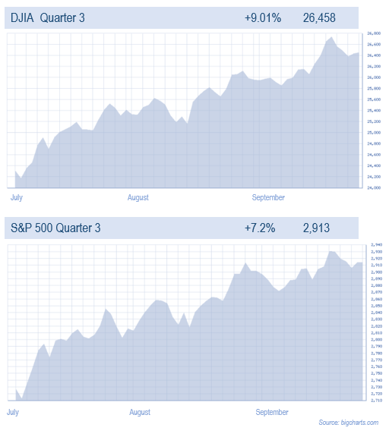
For the third quarter of 2018, the bull market seemed unstoppable. Regardless of the quarter’s concerning short-term events, investors quickly looked beyond those risks and pushed stock prices higher. In February of this year, the markets dipped roughly 10% because of concerns, but this quarter was strong and many major equity indexes moved to all-time highs.
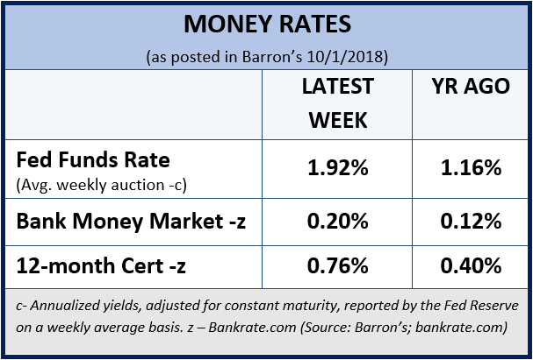
The Dow Jones Industrial Average set an all-time high in September and ended the quarter with an over 9% advance. The S&P 500 index also reached an all-time high in September and finished the quarter with a gain of over 7%.
The S&P 500 posted a six-month winning streak between April and September. This is after recovering from the correction seen in February and March, and during a period that included major fears of a trade war. This is the sixth time since 1928 such a streak took place between April and September,
according to Bespoke Investment Group. Robust economic growth and strong corporate earnings have contributed to these new highs in the indexes. Equity markets have offset concerns of tighter U.S. monetary policy and fears of a global trade war. This current six-month winning streak is the 27th overall dating to 1928.
(Source: CNBC.com 10/2018)

Although equities are high, investors should be cautious, however, much of the economic data for the quarter seemed reasonable. On September 28, the Department of Commerce reported that U.S. consumer spending increased steadily in August at 0.3%, in line with the consensus estimate. Personal income rose 0.3% in August, narrowly missing the consensus estimate of 0.4%. The average wage rate increased by 0.5% in August, the fastest pace since January, and now wage growth is at its highest level since 2009. Retail sales showed growth of over 7% year on year and the Personal Consumption Expenditure (PCE) index grew 0.2% in August. Thanks to that result, the 12-month increase in PCE index is now 2.2%. The core PCE index (excluding food and energy), is the Fed's preferred gauge of inflation measure and it remained steady at 2%, which is a number they like.

In September, U.S. consumer confidence hit its highest level since 2000. The National Unemployment Rate stood at 3.9% through August 2018 and according to the Bureau of Labor Statistics, approximately 201,000 jobs were created in August. Currently, the monthly average of initial jobless claims is at the lowest level since 1969. The National Federation of Independent Business’s survey showed that small businesses were the most optimistic they’ve been since the survey began in 1974. Against this remarkably strong growth backdrop, it’s not surprising that U.S. equities have delivered attractive returns.
Key Points
- Equity Markets made new highs this quarter.
- The bull market is almost 10 years old.
- The Fed raised U.S. Fed Fund rates to 2.00 - 2.25% in September and is planned to raise rates again in 2018.
- Based on historic Price/Earnings (P/E) ratios, equities look expensive.
- Market volatility is back and investors need to continue to be cautious.
- Focus on your personal goals and call us with any concerns.
(Source: JP Morgan 10/1/2018)

Zach’s Research reported that equity markets were fueled by a robust performance by U.S. corporations in the second quarter of 2018. Impressive fundamentals of the U.S. economy, a strong labor market, and the government's deregulation measures, have enabled equity markets to advance, even with trade-related concerns, geopolitical conflicts and inflationary expectations.
(Source: NASDAQ.com 10/1/2018)

The Federal Reserve’s interest-rate hike in late September was the 8th increase since the end of 2015. Over nearly three years, the fed-funds rate has risen from 0.25% to its current range of 2.00% - 2.25%. During this same timeframe, the 10-year Treasury yield has more than doubled to over 3%.

From a broad overall perspective, the bull market that began in 2009 is now approaching 10 years (the second longest bull market ever). This year, investors have seen a correction, but market historians maintain that age does not kill a bull market. Today, equities are not cheap and even the savviest of investors need to have a watchful eye on risk. As financial professionals, we try to make our best forecasts and look for a probability of success understanding we face an uncertain future. Remember, short-term interest rates have risen and cash equivalent yields are still historically low.

Our main goal, as always, is to continually understand our client’s goals and to match those goals with the best solutions.
Interest Rates Are Still in the Spotlight
On Wednesday, September 26th, the Federal Reserve raised interest rates for the third time this year and signaled it will raise rates again in December.
After the end of their September two-day meeting, the Fed increased its target for its benchmark lending rate to a range of 2% to 2.25%. The fed kept the Federal Funds rate near zero from late in 2008 until December 2015. Rates are now at their highest level since the fall of 2008.
At the end of their deliberations, senior Fed officials dropped long-standing language saying its stance on interest rates “remains accommodative.” The unexpected removal of the language would appear to give the Fed more flexibility on how rapidly it raises interest rates next year.
“This rate hike is no surprise, but the removal of the signal that policy is still accommodative will raise a few eyebrows,” said James McCann, Senior Global Economist at Aberdeen Standard Investments.
The Fed’s primary goal is to nudge up short-term interest rates to what it considers a “neutral” level that neither supports nor restricts economic growth.
As reported in MarketWatch.com, “The United States economy is currently running hot: Gross domestic product expanded at a robust 4.2% pace in the second quarter, core inflation is near the Fed’s 2% target and an ever-tightening labor market is forcing firms to boost pay and benefits.”
Based on that economic backdrop, the Fed is prepared to raise rates again before the end of the year. Their meeting notes showed that 12 officials now expect another quarter-point rate hike in December, up from eight officials in the last projections in June. Only four officials now pencil in a pause.
The Fed continues to project three rate increases next year and one more in 2020. This would bring rates into what is considered restrictive territory — more than enough to slow the economy.
The bond market has been behaving as if more rate hikes are coming. Recently, the yield on 10-year Treasury notes have risen slowly but steadily.
The Fed also released a new economic forecast that showed the unemployment rate would rise in 2021 as its restrictive policy starts to bite. In the Fed’s forecast, economic growth will gradually decline over the next three years from a 3.1% annual rate this year to a 1.8% rate in 2020 and 2021.
Some ways rising interest rates can affect the private sector include;
- Rising mortgage rates and higher mortgage payments reduce home affordability and hurt home turnover and re-financings.
- Slowing home sales and reduced re-financings hurt spending on renovations and remodeling.
- Given record-high auto prices and the difficulty in further lengthening out already long auto loan maturities, rising interest rates will hurt auto sales by raising monthly payments.
- Consumer, mortgage and corporate loans that are variable rate are hurt by climbing interest rates.
- The credit markets fall when interest rates rise, having a negative wealth effect on consumers and corporations that own bonds.
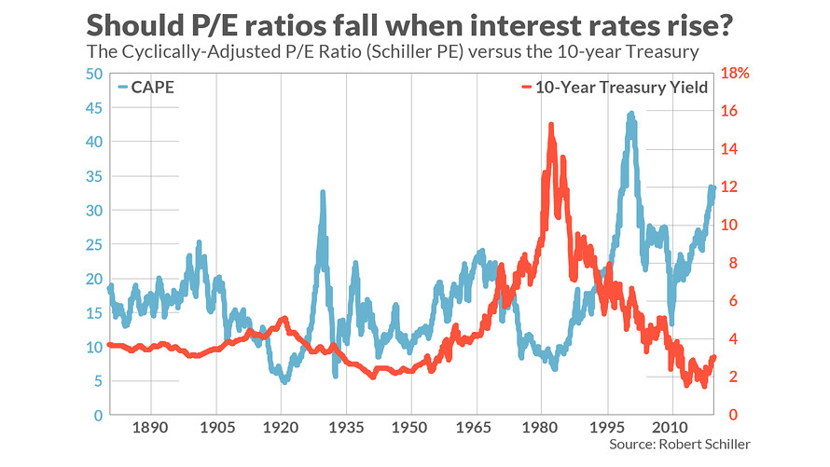
- Corporate capital spending depends partially on borrowings. Higher borrowing costs could lead to lower capital spending.
- Rising interest rates impede corporate profit margins, overall profits and earnings per share.
- Debt is often issued by corporations to buy back stock and pay dividends. Advancing rates reduce a company's return on investment on those buybacks.
For now, higher short-term interest rates seem likely, so investors still need to keep a watchful eye on interest rates.
Interest Rates and P/E Ratios
According to some analysts and advisors, higher than historical Price Earnings (P/E) ratios were once justified by low interest rates. In December 2015, when the Federal Reserve began its current round of rate hikes, the P/E ratio stood at 16.0 (according to FactSet, when calculated on earnings estimates over the subsequent 12 months). Today, the comparable P/E stands at 17.5.

On September 25th, Nobel Prize winner and legendary Yale Professor Robert Shiller stated on CNBC that, “earnings are volatile”. He also cautions that a bear market could come without warning. Shiller also said that, "The market could go up for years. I'm not very able to predict turning points. I do think it’s risky now. This is a risky time, especially investing in the U.S. – the most expensive country in the world".

A big question for investors is, if low interest rates justified higher P/E ratios, as the bulls have argued for much of the last decade, consistency would require them to argue that with interest rates rising, P/Es should now be lower. A landmark finding in an older issue of the Journal of Portfolio Management states, the “obvious” conclusion to draw is that “when P/Es are high (low), forecasted 10+ year real stock returns are low (high), regardless of starting interest rates.”

As interest rates move, we will need to carefully watch corporate earnings to monitor how they perform.
Tariffs
A big and obvious near-term risk to the global economy is the potential for a further escalation in trade tariffs emanating from the U.S., and the subsequent retaliation. As of the quarter’s end, the U.S. is imposing tariffs on about $250 billion of imports from China, and China has retaliated with tariffs on about $110 billion of U.S. exports to China. The current tariff rate on all of China’s exports to the U.S. is scheduled to increase in January if a deal cannot be reached. Trade negotiations also had good news this quarter. A new deal to replace the North American Free Trade Agreement (NAFTA) was signed.
(Source: JPMorgan 10/1/2018)
Tariffs and trade issues could affect equities, so investors need to continue to monitor them.
What Should an Investor Do?
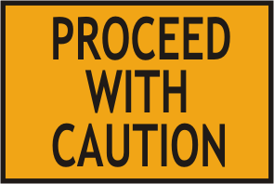
The mere mention of October is sometimes enough to frighten some investors. Newer investors can wonder, “What’s the big deal?” It all comes down to perspective. Five of the stock market’s worst 10 days ever happened in October, including 1987’s more-than 20% single day drop. Overall, October is an average month for the market, but it has one of the higher incidences of volatility. Market volatility is typical in the investment world. Experienced investors understand that volatility is a part of investing. They also understand that more important than the volatility is an investor’s response to that volatility. Sometimes volatility is a sign of heightened risk, but at other times volatility is just a normal part of investing. Market volatility is possibly one of the most misunderstood concepts in investing. Simply put, market volatility is a statistical measure of when the equity markets rise or fall sharper than usual within a short period of time.
In their Market Review and Outlook for September 2018, NASDAQ.com sites that despite, “warning signs, the economic and corporate outlook in the U.S. remains constructive and equities are in a bull market. The fiscal stimulus, deregulation, and generational tax reform are fueling the U.S. economy and driving global outperformance. Concerns exist with persistent Fed tightening, a flat curve, a strengthening dollar, trade with China, and an overseas slowdown which may come home to roost at some time, but for now the U.S. is performing and consumers are spending.” In their report they suggest that, “Advice from a securities professional is strongly advised”.
(Source: NASDAQ.com 10/1/2018)

According to market analysts, the outlook for year-end remains mixed. Some professionals on Wall Street forecast the S&P 500 will end the year slightly higher than its current level — up 1.7%, to be precise, according to the average forecast of strategists surveyed by CNBC. On the flip side, among other prognosticators who are very concerned, there’s near-daily talk of an imminent market crash.
(Source: NerdWallet.com 9/28/2018)
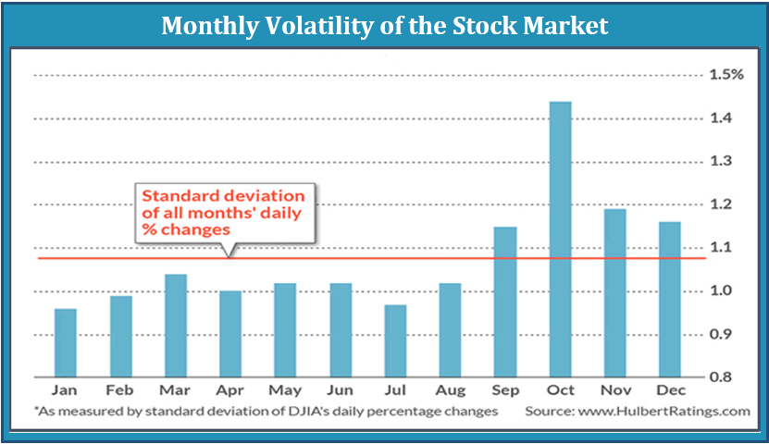
As our graph of volatility shows, since 1896 when the Dow Jones Industrial Average was first created, the market’s volatility is higher in October than in other months (this is true even if 1987 and 2008 were excluded). This quarter may bring a volatile investment environment, so we thought it would help to continue our theme of sharing strategies to think about during volatile times.
Things to Consider in Times of
Market Volatility
- Revisit your financial goals and objectives.
Investors should always put their primary focus on their own personal goals and objectives. When equity markets become volatile sometimes even the best investors become not just concerned, but unnerved. It’s important to keep perspective when markets are volatile. It is very important that you understand your situation and your financial plan. Letting your emotions drive your decisions can be costly. Here are strategies that money managers consider when making decisions.
- Always allocate your investments to match your risk tolerance.
- If possible, add money to your investments regularly and try to increase your additions during downfalls.
- It’s nearly impossible to always time the market right (sell when you think the markets at its peak), so have a strategy.
- Accept that volatility is inherent to investing, but not something to stress about for long-term investors.
- Consider avoiding or ignoring nightly financial news.
- Always try not to make any emotional decisions.
If you are concerned with your investments or goals, or risk tolerance levels have changed, call us.
While CDs and money market funds offer the highest level of safety, they still are offering low returns. Full market risk is not appropriate for most investors even though today's traditional fixed rates might not help many investors to achieve their desired goals. Most investors attempt to build a plan that includes risk awareness. Often, this can lead to safer but lower returns. Traditionally, bonds have been used as a hedge against market risk, but with interest rates projected to rise, investors should be extremely cautious.
We focus on YOUR
personal goals and Strategy.

During confusing times, it is always wise to have realistic time horizons and return expectations for your own personal situation and to adjust your investments accordingly.
Now is the time to make sure you are comfortable with your investments.
Equity markets will continue to move up and down. Even if your time horizons are long, you could see short-term downward movements in your portfolios. Each type of investment poses a certain level of risk and offers a level of potential reward. It’s always a good idea to regularly re-evaluate your portfolio and your level of risk exposure. Peaks and valleys have always been a part of financial markets and is highly likely that trend will continue.
Discuss any concerns with us.
Our advice is not one-size-fits-all. We will always consider your feelings about risk and the markets and review your unique financial situation when making recommendations. If you would like to revisit your specific holdings or risk tolerance, please call our office or bring it up at our next scheduled meeting.

We pride ourselves in offering:

- consistent and strong communication,
- a schedule of regular client meetings, and
- continuing education for every member of our team on the issues that affect our clients.
A skilled financial advisor can help make your journey easier. Our goal is to understand our clients’ needs and then try to create a plan to address those needs. If you need to discuss your investments, please call us.

Oil prices have risen this year! …and that affects gas prices!
U.S. Energy Information Administration pricing data show just how wide the swings can be.

$2.87 a gallon on October 1, 2018 up almost 40¢ from a year ago.
$4.16: July 7, 2008 - 21st century high
$1.10: Dec. 12, 2001 - 21st century low

Please share this report with others!
This year, our goal is to offer services to several other clients just like you! If you would like to share this report with a friend or colleague, please call Marlena at Superior Financial Management (516) 939-2789 and we would be happy to assist you!

Prices based on U.S. averages including taxes

Chuck Schlapp is a Financial Planner with Superior Financial Management. He is a registered investment advisor affiliated with and also offers securities as a Registered Representative of North Ridge Securities Corp.
1895 Walt Whitman Road, Melville, NY 11747. Tel.: (631) 420-4242 – Member of FINRA/SIPC.

Note: The views stated in this letter are not necessarily the opinion of North Ridge Securities Corp., and should not be construed, directly or indirectly, as an offer to buy or sell any securities mentioned herein. Investors should be aware that there are risks inherent in all investments, such as fluctuations in investment principal. With any investment vehicle, past performance is not a guarantee of future results. Material discussed herewith is meant for general illustration and/or informational purposes only, please note that individual situations can vary. Therefore, the information should be relied upon when coordinated with individual professional advice. This material contains forward looking statements and projections. There are no guarantees that these results will be achieved. All indices referenced are unmanaged and cannot be invested into directly. Unmanaged index returns do not reflect fees, expenses, or sales charges. Index performance is not indicative of the performance of any investment. The S&P 500 is an unmanaged index of 500 widely held stocks that is general considered representative of the U.S. Stock market. Dow Jones Industrial Average (DJIA), commonly known as “The Dow” is an index representing 30 stock of companies maintained and reviewed by the editors of the Wall Street Journal. Past performance is no guarantee of future results. Due to volatility within the markets mentioned, opinions are subject to change without notice. Information is based on sources believed to be reliable; however, their accuracy or completeness cannot be guaranteed.

Sources: Barron’s, FactSet, JP Morgan, Nerdwallet.com, NASDAQ.com, CNBC, The Wall Street Journal; Academy of Preferred Financial Advisors, Inc.©2018

